**Contents**

1 Introduction 3

1.1 Purpose of the manual 3

1.2 Technical knowledge required 3

1.3 Manual validation 3

1.4 technical support 3

2 safety tips 4

3 Description 4

3.1 Basic description 4

3.2 Technical Specifications 4

3.3 Module dimensions 5

4 Installation 6

4.1 Observe EMC items 6

4.2 Cases that cause system malfunctions 6

4.3 Things to consider 6

5 connections 7

5.1 Connections group 7

5.2 Power supply connection 7

5.3 current input (connection to current transformer) 8

5.4 Analog output signal 8

5.5 RS485 connection 9

6 parameters 10

6.1 Communication parameter 10

6.2 Module information parameter 11

6.3 Parameters of current digital values 11

1. Introduction
   1. Purpose of the manual

This manual contains all the information needed to set up, install, wiring and communicate with the PM-CT11A module.

* 1. Technical knowledge required

In order to understand this booklet, a basic acquaintance with electrical topics is required.

* 1. Manual validation

This booklet is valid for this specification.

|  |  |  |
| --- | --- | --- |
| Software | Hardware | MODEL |
| V1.1 | V1.1 | PM-CT11A |

* 1. technical support

To get technical support through the following contact:

❖      Email: **info@parsmega.com**

❖      Phone: **+98 21 91009955**

❖      WhatsApp: **+98 9981122566**

1. safety tips

* Starting the module by non-experts and ignoring the commands may cause serious damage to the module.
* This module does not directly pose a risk to human life.
* The use of this module is not approved for use in life-threatening devices.

1. Description
   1. Basic description

PM-CT11A is a CT current transformer converter to standard analog signal and digital value. This module is by default for connecting to current transformer with 5 amp output. This module has the ability to connect to the computer and control equipment such as (HMI and PLC) through the RS485 serial port. It also has the ability to convert the output current of the current transformer to the following standard analog signals.

* 0-10V
* 0-5V
* 0-20 mA
* 4-20 mA
  1. Technical Specifications
* Wide range of port 485 baud rate (from 2400 to 230400)
* Module status LED Indicator
* 10-bit Analog to Digital converter
* 1 CT input
* Working temperature range: -30 ~ +75 degrees Celsius
* RS485 serial communication with MODBUS protocol support
* Current and voltage analog output
  1. Module dimensions

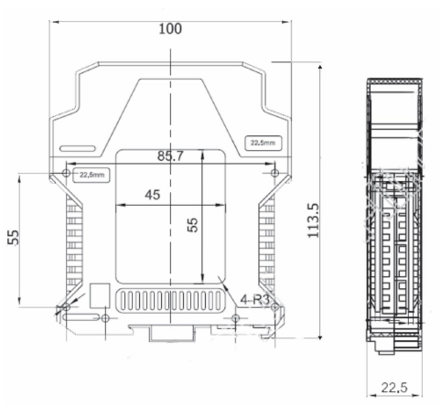

1. Installation
   1. Observe EMC items

This product is designed and manufactured to work in industrial environments. However, for proper operation, you should check and eliminate the issues that cause the module to malfunction.

* 1. Cases that cause system malfunctions
* Electromagnetic field
* Telecommunication cables
  1. Things to consider
     1. Convenient ground connection
* When installing the module on the panel body, make sure that the panel body is connected to the ground.
* All ineffective metal parts are (firmly) grounded.
* When connecting varnished wires to ground connection, remove the varnish from that part.
  + 1. Appropriate wiring method
* Divide your system cables into different groups (high voltage, power supply, and signal, analog).
* Always transfer the power cable from another duct.
* Always place your analog cables close to the body of the panel and rails (which are grounded).
  + 1. Cable shield connection
* Make sure the shields are properly grounded.
* Try to keep a small part of the cable without a shield.

1. connections

All connections of this module are screws.

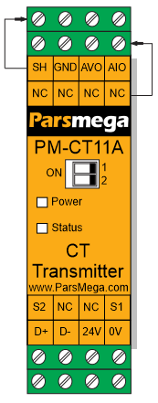

* 1. Connections group

The connections of this module include 4 main groups:

* Power
* Current input (connection to current transformer)
* Analog output
* RS485 serial
  1. Power supply connection

The proper power supply for this module is 24 v dc, otherwise the device will not function properly.

Terminal 0 V

terminal 24 V

* 1. Current input (connection to current transformer)

The PM-CT11A module has the ability to connect to the output of a current transformer (by default, a transformer with an output of 5 amps). The labels of the terminals as well as the function corresponding to each terminal are as follows:

|  |  |
| --- | --- |
| Function | Label |
| Input number one of the current transformer (COM) | S1 |
| Input number two current transformer | S2 |

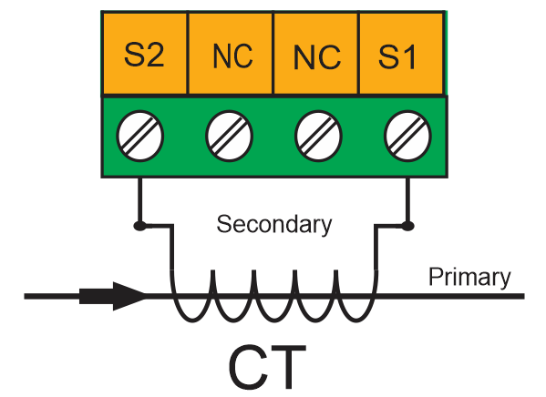

* 1. Analog output signal

Analog output has several modes:

* 4~20 mA
* 0~ 20 mA
* 0~ 5 V
* 0~ 10 V

Terminals related to the output analog signal:

|  |  |
| --- | --- |
| Function | Label |
| Analog voltage output | AVO |
| Analog current output | AIO |
| Output analog return path | GND |
| shield | Sh |

**Note**: In current mode, the **maximum** resistance in series with the loop is 300 ohms.

**Note**: In voltage mode, the **minimum** load resistance is 1 kilo ohm.

By using the dip switch on the transmitter panel, you can determine the type of analog output signal:

|  |  |  |
| --- | --- | --- |
| Dip switch two | Dip switch one | Output analog signal type |
| Off | Off | 4-20mA |
| On | Off | 0-20 mA |
| Off | On | 0-5V |
| On | On | 0-10V |

* 1. RS485 connection

This module is equipped with an RS485 serial port on which the MODBUS RTU protocol is implemented.

|  |  |
| --- | --- |
| Function | Label |
| Positive data | D+ |
| Negative data | D- |

Below is how to connect the power supply and serial port to the module:

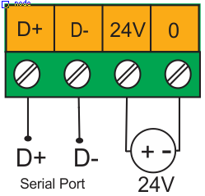

1. parameters

All parameters are set with default values at the time of purchase.

For ease of work, the parameters are divided into different groups.

* The length of all variables is word
* Some parameters need to be restarted to apply changes.

|  |  |  |  |  |  |  |
| --- | --- | --- | --- | --- | --- | --- |
| Default | Description | Address | Reading Writing | Length | Variable Type | Title |
| 1 | 1~247 | 0  40001 | R/W | 1 | Unsigned int | ID |
| 2 | 0~10 0=2400 1=4800 2=9600 3=14400 4=19200 5=28800 6=38400 7=57600 8=76800 9=115200 10=230400 | 1  40002 | R/W | 1 | Unsigned int | Baud Rate |
| 2 | 0=none 1=odd 2=even | 2  40003 | R/W | 1 | Unsigned int | parity |
| 0 | 0=1 1=2 | 3  40004 | R/W | 1 | Unsigned int | Stop bit |
| - | 0=RTU  1=ASCII(8bit)  2=ASCII(7bit) | 4  40005 | R/W | 1 | Unsigned int | Comm Mode |

* 1. Communication parameter

Note that the converter is reset once to apply the above parameters.

* 1. Module information parameter

All the following parameters are ­ read only

|  |  |  |  |  |  |  |
| --- | --- | --- | --- | --- | --- | --- |
| Default | Description | Address | Read/  Write | length | Variable type | Title |
|  |  | 6  40007 | R | 2 | Float | Firmware ver |
|  |  | 8  40009 | R | 2 | Float | Hardware ver |
|  |  | 10  40011 | R | 1 | Unsigned int | Model |
|  |  | 11  40012 | R | 2 | Unsigned long | Serial number |

* 1. Parameters of current digital values

|  |  |  |  |  |  |  |
| --- | --- | --- | --- | --- | --- | --- |
| Default | Description | Address | Read/  Write | length | Variable type | Title |
|  | 0~1023 | 14  40015 | R | 1 | Unsigned int | ADC raw data |
|  |  |  | R |  |  |  |

ADC raw data parameter displays the converted value of 0-5A current as 0-1023.